**Task # 1:** Take any integer as input, if the number is greater than 5 print

* If a >5, print a
* Else if a = 0, then Halt
* Else if a < 5, then halt

**Code:**

In Input Integer "a"

brz 05 If a == 0 than go to line # 05

sto 98 store value of a at address 98

sub 99 a - 5

brp 06 if a > 5 (Go to Line # 06)

hlt terminate program

lda 98 Load Value a

out print Value a

hlt Terminate Program

*99

Dat 005 Value 5

**Output:**

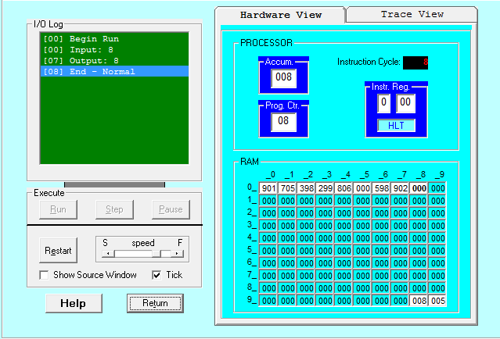

**Task # 2:** Take two numbers as input and print the larger number

**Code:**

In Input A

sto 98 Store A at address 98

In B Input B

sto 99 Store B at address 99

sub 98 Subtract B - A

brp 09 If B > A (ans of sub = +ve)

lda 98 Load A (Value of A stored here)

out print A

hlt Terminate program

lda 99 Load B (Value of B stored here)

out Print B

hlt Terminate Program

**Output:**

